Theta Mix Patch Notes Wednesday 6/20/2018

To use these features, you must have the latest version of Theta Mix for Windows or Mac.

*Download here:*

<https://github.com/Franimal/theta-ar-scripts/raw/master/Builds/ThetaMix_OSX.app.zip>

<https://github.com/Franimal/theta-ar-scripts/raw/master/Builds/ThetaMix_Windows.zip>

**Sound**

You now can create sound objects in your mixes using .wav files.

For a bunch of free sounds to use in your mixes, you can go here <http://bbcsfx.acropolis.org.uk>

To get the link, right click the “Download” button of the sound you want and click “Copy Link Address”.

In your script, write the following in the setup() function:

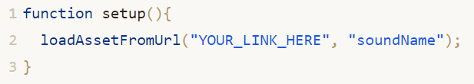

Paste your sound URL where mine says “YOUR_LINK_HERE” and make the soundName whatever you want. I found some wildlife sounds to put in mine:



To use this, you need to create an object that will have the sound on it. You can do this anywhere except setup(). Here I made one at the start and told it to move away from the player.

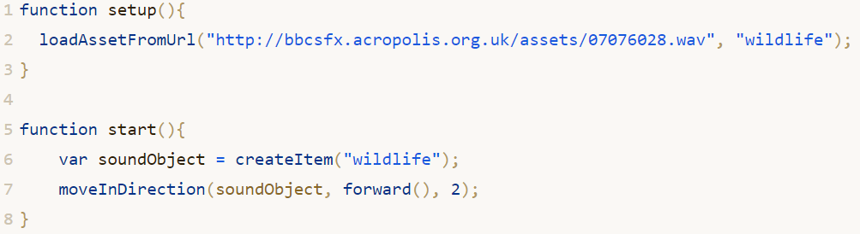

To play the sound, just do this (you can also stop and loop them):



*You can find this example script here:*

[*https://theta-mix.azurewebsites.net/app/viewscript/19c1ae57-1f2d-44e5-a9d4-80bcb35840ed*](https://theta-mix.azurewebsites.net/app/viewscript/19c1ae57-1f2d-44e5-a9d4-80bcb35840ed)

**More Input for Desktop**

You can now access whether a key is pressed:



And whether a mouse button is pressed:

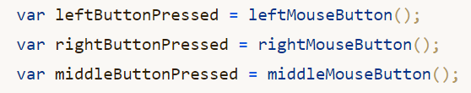

And whether the scroll wheel has been scrolled:



For example, to allow the player to fire fully automatically in our lightning shooter game, you can add this into the update function:

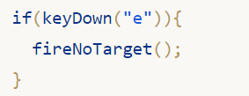

**Projectile Speed and Damage**

You can now change a projectiles speed and damage, like so (you can also change the Lifespan):

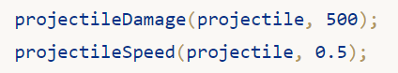

Make sure you do this before you fire it!

**Floor**

You can create a floor with the following function:



In this example, I’ve made a floor that is 10 squares across, and is set at the default height.

You can use this floor like you can use any object, so you can do things like set the texture:

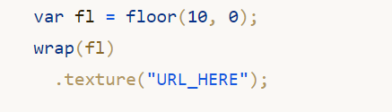

**Render Order**

You can use this to set order that an object renders in the scene. By default, transparent objects are at 3000. An example usage of this is ensuring that our crosshair renders correctly by giving it 1 higher than other transparent objects:

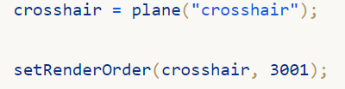

**Disable default cursor on desktop**

On desktop, you can now use disableCursor() to get rid of the default cursor.